Practical 4:

Video : <https://www.youtube.com/watch?v=0MaS0nZCTZc>

Virtualbox: <https://www.virtualbox.org/wiki/Downloads>

Ubuntu image: <https://drive.google.com/drive/u/0/folders/1me_nJJh0fvdDOXX3ew2jzGQpoP7f_iFt>

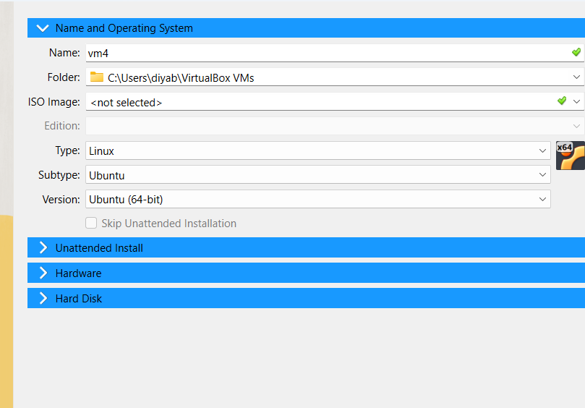

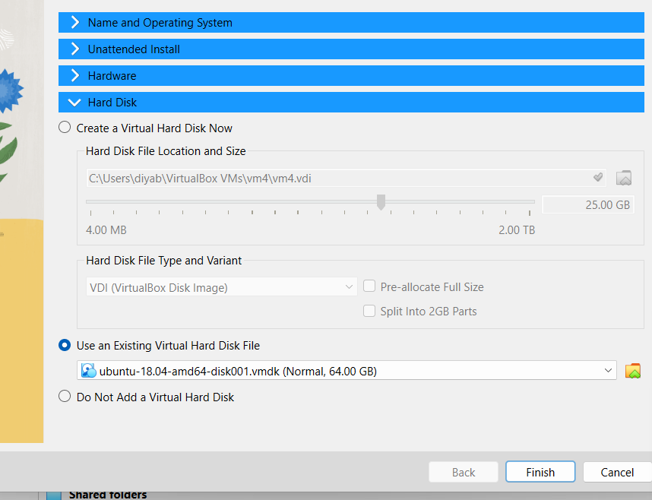

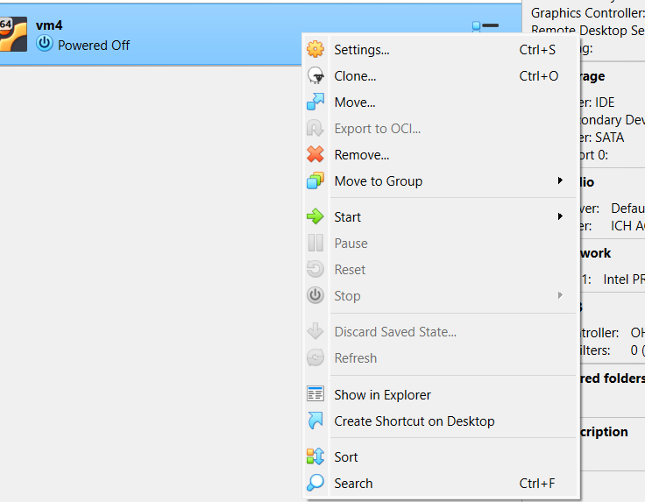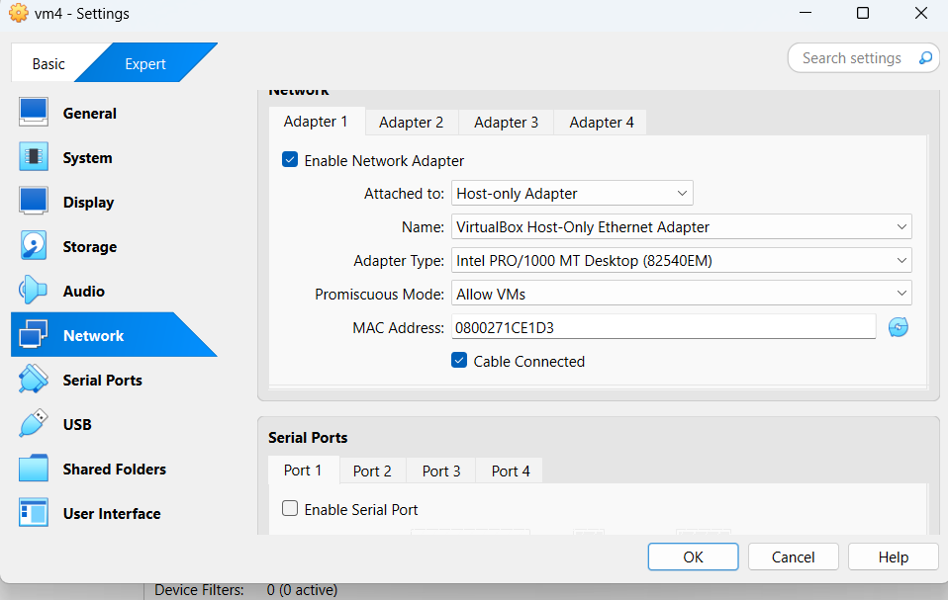

Vm1:

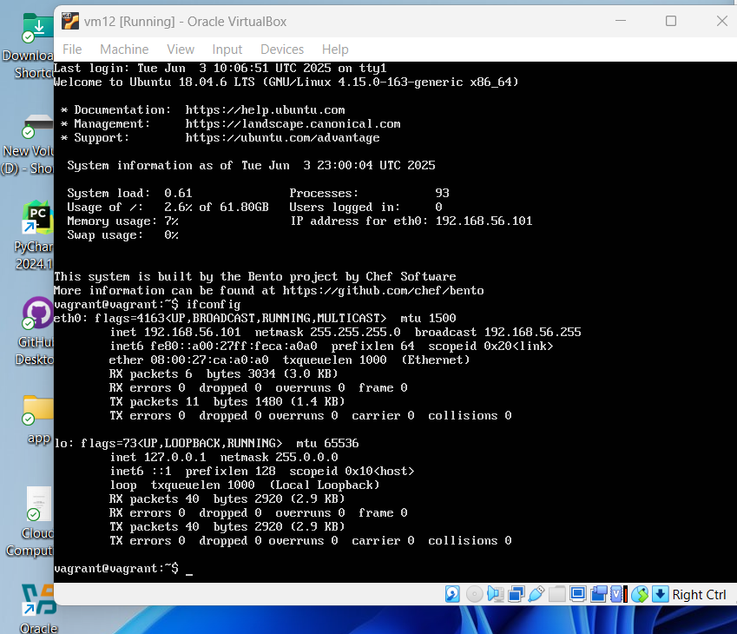

Usename : vagrant

Password : vagrant

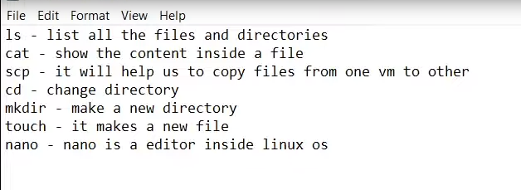

Commands:

Ifconfig -> run for both in starting

ping 192.168.56.102 ->vm1

touch hii.txt ->vm1

nano hii.txt ->vm1

cat hii.txt ->vm1

scp hii.txt [vagrant@192.168.56.102:/home/vagrant](mailto:vagrant@192.168.56.102:/home/vagrant) ->vm1

ls /home/vagrant ->vm2

Vm2:

